**（Screenshot presentation of GitHub.）**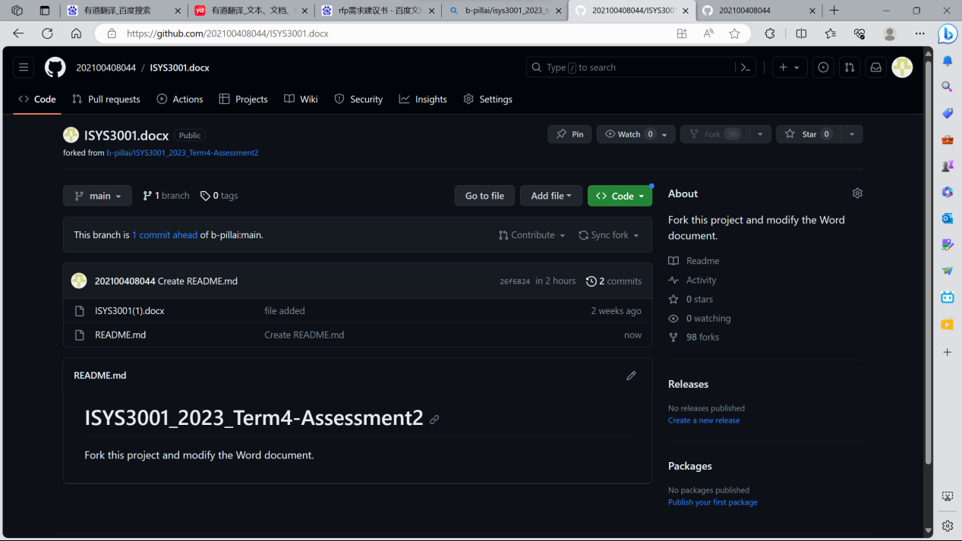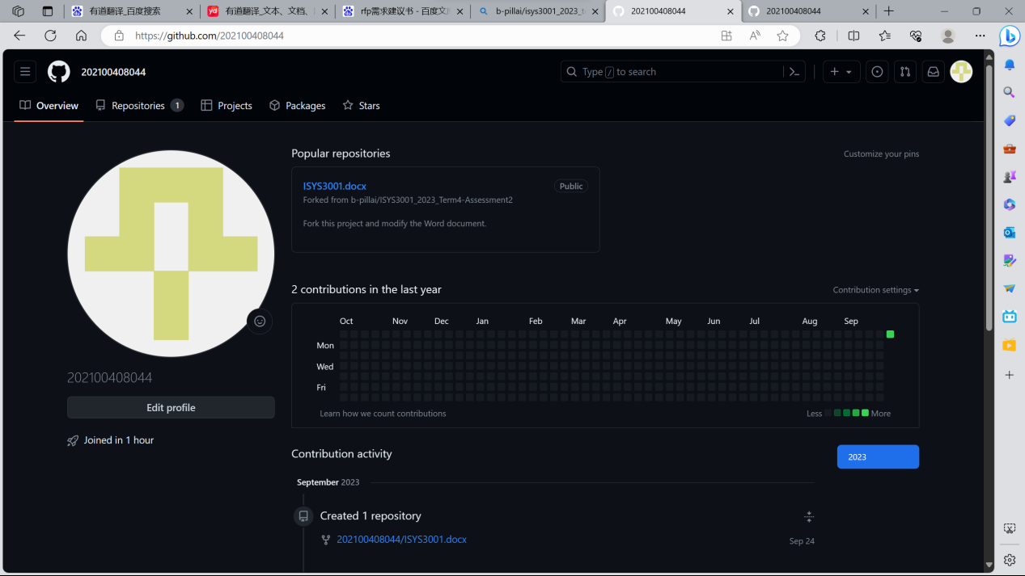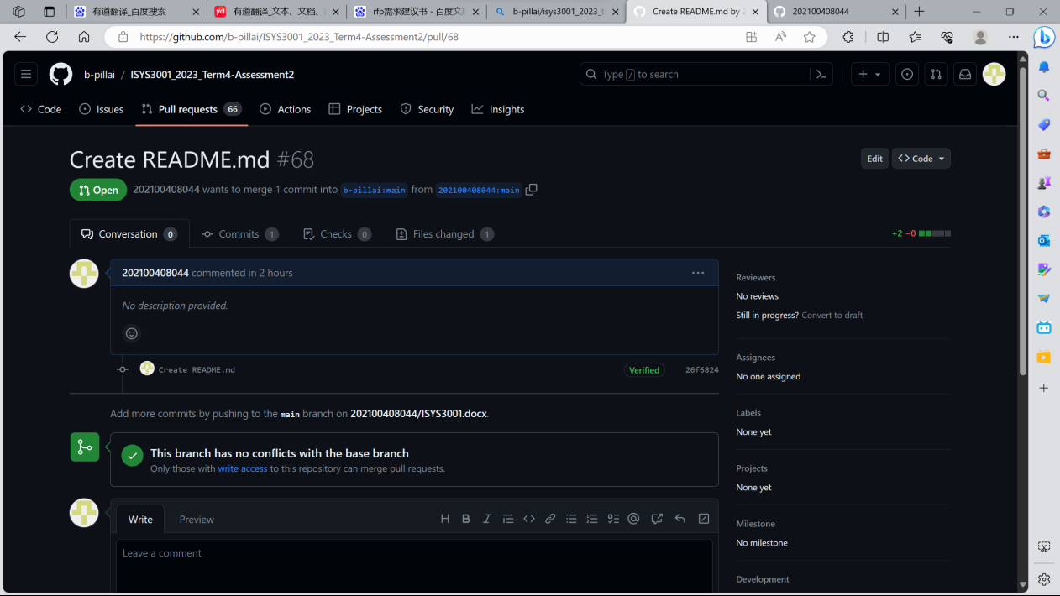

# Configuration Management

### Change Management :

Implement a robust change management process to address issues caused by silo development. Promote open communication between developers and establish clear modification procedures. Use version control tools to track code changes and ensure that all changes are recorded, reviewed, and approved before implementation. Establish a change control committee to oversee these processes and ensure that all changes are consistent with project objectives and adequately documented to minimize risks associated with changes.

### Version Management:

Develop a version management strategy to improve consistency and traceability. Implement a version control system like Git to track code changes across all projects. Ensure that all developers follow best version control practices, including branching, tagging, and merging, to avoid conflicts and help identify the cause of issues. Document version control conventions and encourage developers to follow them consistently to improve project visibility and reduce integration issues.

### System Building :

Promote collaboration and consistency in system building through DevOps practices. Encourage developers to work closely together, break isolation, and promote cross-functional teams including developers and operators. Automate the build process using tools such as Continuous Integration/Continuous Deployment (CI/CD) pipelines to ensure build consistency and reliability. In-depth testing is carried out at each development stage to identify integration issues as early as possible and reduce the likelihood of costly delays.

### Release Management:

Modify your release management methods to ensure smooth deployment. Create a clearly defined release plan that includes clear milestones, timelines, and a rollback process in case of issues. Automate deployment processes to minimize human errors and standardize approval processes. Perform rigorous testing in a stage environment that closely matches the production environment to identify potential integration issues before they reach the active environment. Finally, you can comprehensively document the release process so that all team members can easily understand and follow the steps for releasing new software versions.

# Request for Proposal (RFP)

### Title: Integrated System for Aussie Business Buzz (ABB)

### 1. System Description

1.1 Project Background

ABB is a company that distributes various technology products such as PCs, laptops, smartphones, routers, as well as device maintenance and accessories for mobile devices. We have four branches and plan to expand to other locations in the future. To better manage our business, we need a comprehensive system.

1.2 Initial requirements

Our preliminary requirements are as follows:

（1）Customer Relationship Database: Contains detailed customer information, customer purchase history, issue reports, and maintenance work details.

（2）Marketing system: Supports digital marketing, including modern marketing technologies such as email and social media. It should be able to use detailed information from the customer relationship database and allow for the addition of other potential customer information.

（3）Inventory management system: including unsold products, repair parts, and automatic ordering by wholesalers. Must be able to manage inventory at all locations.

（4）Management report: Report customer relationships, marketing, inventory, and other information to management for decision-making purposes.

1.3 Future Development of the System

We anticipate that this system will evolve over time and therefore require flexibility to accommodate future extensions and enhancements. Please consider this in your proposal.

### 2. Evaluation Proposal

We will evaluate your proposal based on the following criteria:

* Quality and adaptability of technical solutions.
* Cost effectiveness and budget rationality.
* Schedule and delivery capability.
* Availability of services and support.
* Integration capability with ABB's current system.

Please ensure that your proposal clearly explains how your solution meets these standards.

### 3. Questions and Answers

If you have any questions or need further clarification regarding this RFP, please contact us through [call：15267514458]. We will provide additional information or answer questions as needed.

### 4. Invitation

We encourage innovation and creativity, so although we have made preliminary requirements, we welcome you to provide alternative solutions or suggestions. We hope that your proposal is as flexible as possible so that you can provide us with the most suitable solution.

Thank you for your interest in Aussie Business Buzz. Please submit your proposal by [2023.10.1]. We look forward to receiving your proposal and working with you to build a strong system to support our business growth